Space Diagonal
# Source: AI Source: Provided by: [Data Path: Persons Table -> ID Column: 1, Name_En Column: Motasem Essam] -> From: [ChatGPT] on [7/25/2026]
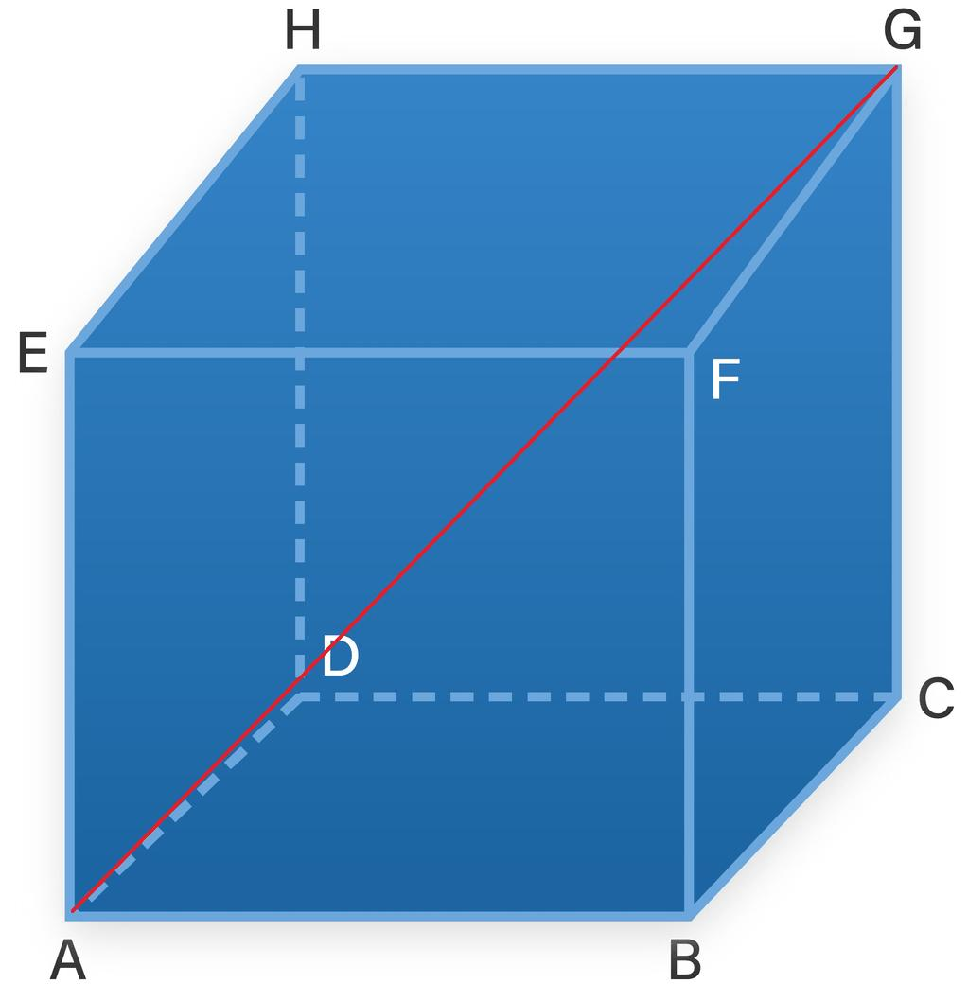
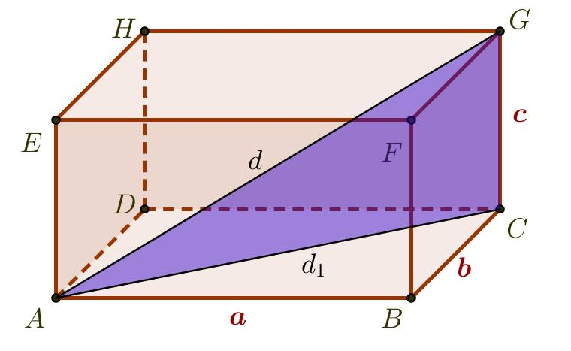
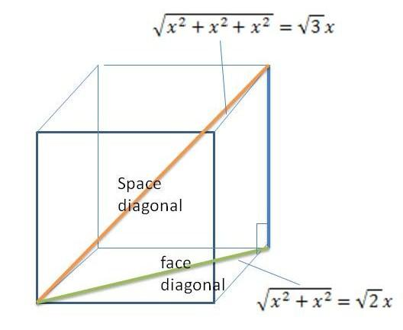

Definition
# Source: AI Source: Provided by: [Data Path: Persons Table -> ID Column: 1, Name_En Column: Motasem Essam] -> From: [ChatGPT] on [7/25/2026]
A space diagonal is a line segment inside a three-dimensional solid that connects two vertices that do not lie on the same face. It passes through the interior of the solid and connects opposite vertices.
A space diagonal differs from a face diagonal because a face diagonal lies entirely within one face, whereas a space diagonal extends through the solid's three-dimensional interior.
For example, in a cube, a space diagonal connects one corner of the cube to the corner directly opposite it.

Simple definition
# Source: AI Source: Provided by: [Data Path: Persons Table -> ID Column: 1, Name_En Column: Motasem Essam] -> From: [ChatGPT] on [7/25/2026]
A space diagonal is a straight line segment that connects two opposite vertices of a 3D solid through its interior.
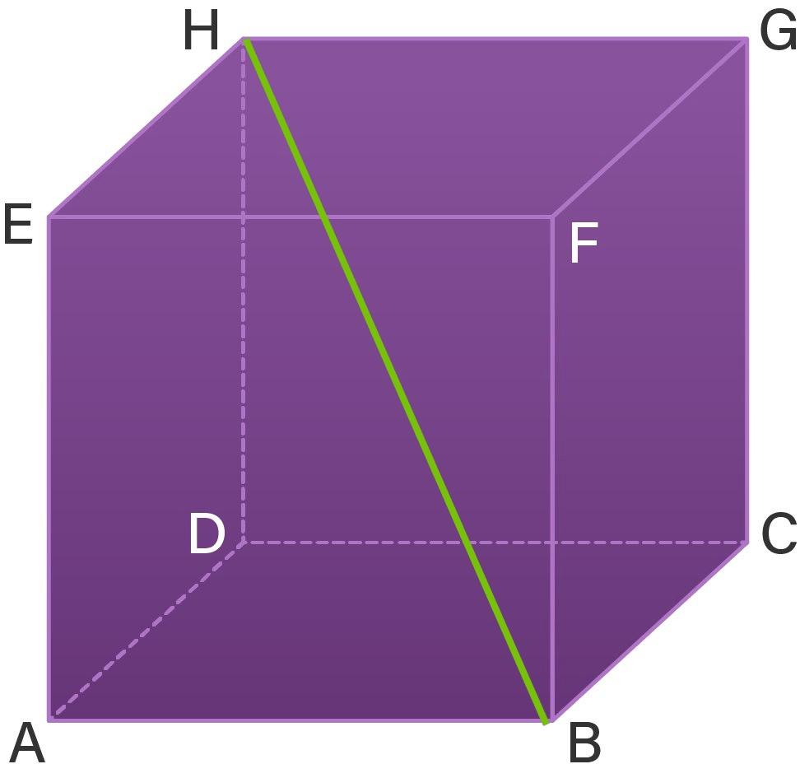
Illustration: the space diagonal passes through the interior of the cube.

Key characteristics
# Source: AI Source: Provided by: [Data Path: Persons Table -> ID Column: 1, Name_En Column: Motasem Essam] -> From: [ChatGPT] on [7/25/2026]
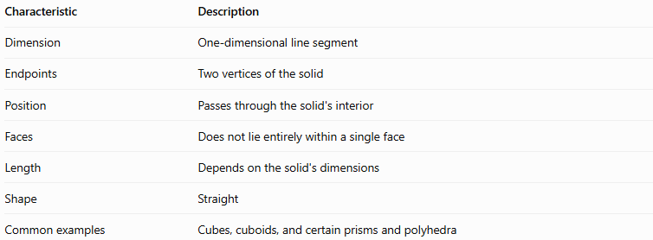
Characteristic | Description
Dimension | One-dimensional line segment
Endpoints | Two vertices of the solid
Position | Passes through the solid's interior
Faces | Does not lie entirely within a single face
Length | Depends on the solid's dimensions
Shape | Straight
Common examples | Cubes, cuboids, and certain prisms and polyhedra
A space diagonal is not an edge: an edge lies on the boundary of a solid, while a space diagonal connects vertices through its interior.

Types and examples of space diagonals

A. Space diagonal of a cube
# Source: AI Source: Provided by: [Data Path: Persons Table -> ID Column: 1, Name_En Column: Motasem Essam] -> From: [ChatGPT] on [7/25/2026]
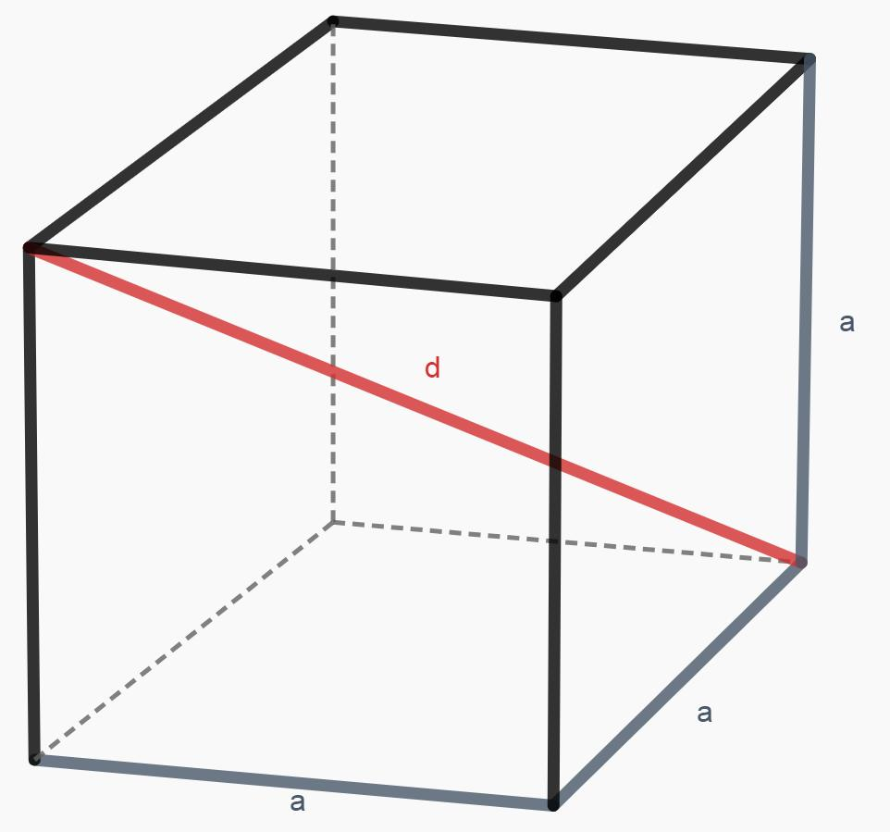
A cube has six square faces and eight vertices. Each vertex has one opposite vertex, producing four distinct space diagonals.
If the cube's edge length is $a$, the space diagonal is:
$$\boxed{d=a\sqrt{3}}$$
This formula follows from the three-dimensional Pythagorean theorem.

B. Space diagonal of a cuboid
# Source: AI Source: Provided by: [Data Path: Persons Table -> ID Column: 1, Name_En Column: Motasem Essam] -> From: [ChatGPT] on [7/25/2026]
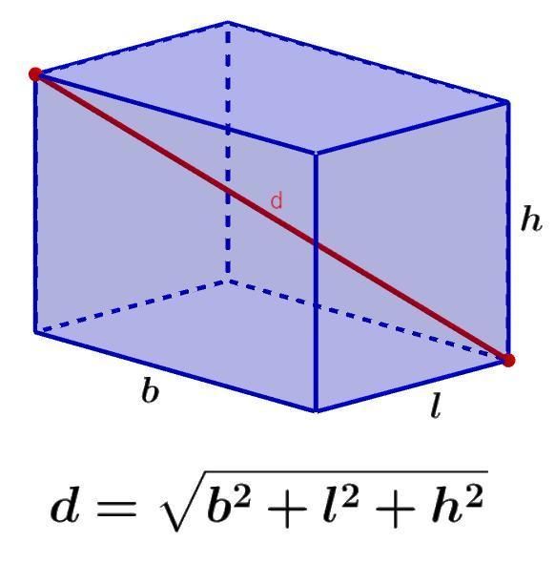
A cuboid has length $l$, width $w$, and height $h$. Its space diagonals all have the same length.
$$\boxed{d=\sqrt{l^{2}+w^{2}+h^{2}}}$$
The formula applies to rectangular boxes, including boxes whose three dimensions are different.

C. Space diagonal in other polyhedral
# Source: AI Source: Provided by: [Data Path: Persons Table -> ID Column: 1, Name_En Column: Motasem Essam] -> From: [ChatGPT] on [7/25/2026]
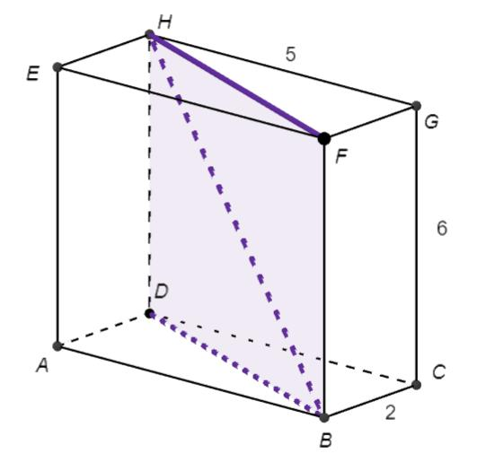
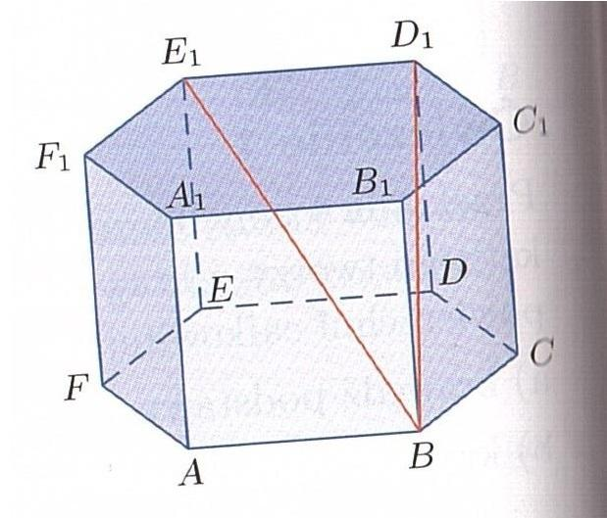
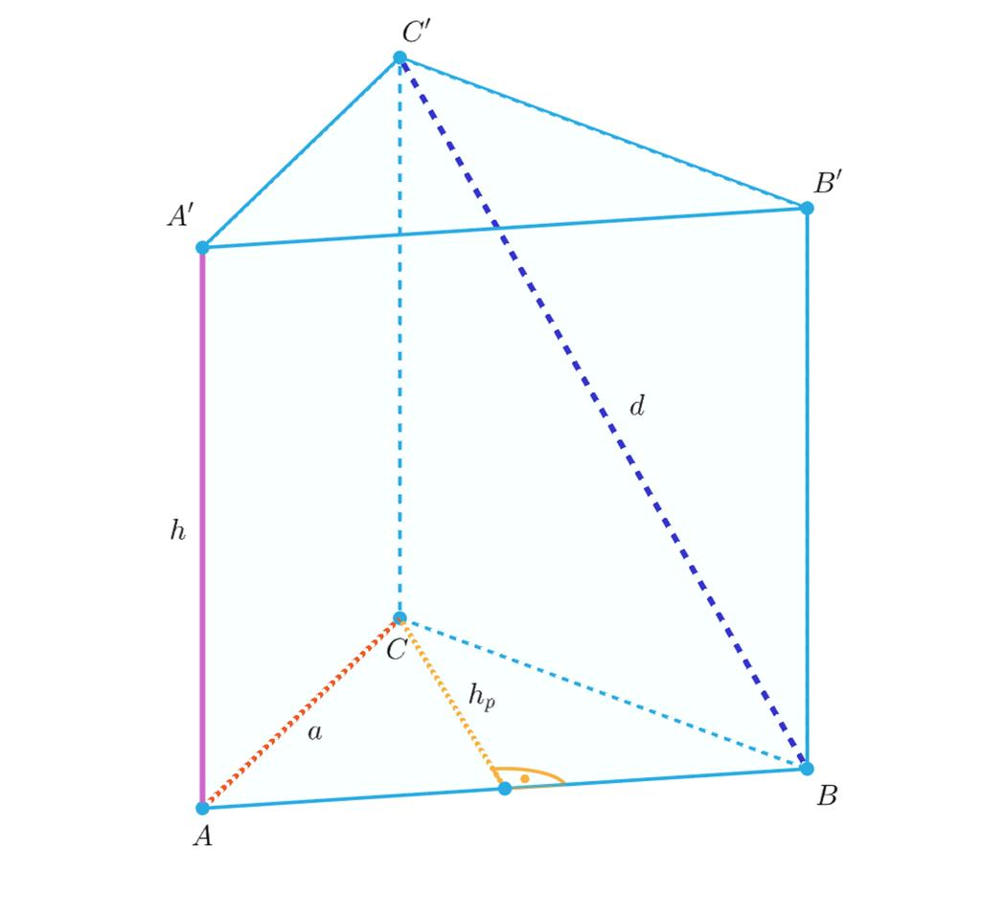
7
Space diagonals can also occur in other polyhedra, but their number and lengths depend on the solid's shape.
- Prisms: some pairs of vertices on different faces can be joined by space diagonals.
- Other polyhedra: a segment joining two vertices is a space diagonal if the vertices do not share an edge or a face and the segment passes through the interior.
- Not every solid has a space diagonal: a tetrahedron, for example, has no space diagonals under the usual definition because every pair of its vertices belongs to an edge.

Mathematical formulas

A. Space diagonal of a cube
# Source: AI Source: Provided by: [Data Path: Persons Table -> ID Column: 1, Name_En Column: Motasem Essam] -> From: [ChatGPT] on [7/25/2026]
Let the cube's side length be $a$.
First, calculate the face diagonal using the Pythagorean theorem:
$$f=\sqrt{a^{2}+a^{2}}=a\sqrt{2}$$
Then use the face diagonal and the third edge to calculate the space diagonal:
$$d=\sqrt{f^{2}+a^{2}}$$
Substitute $f=a\sqrt{2}$:
$$d=\sqrt{2a^{2}+a^{2}}=\sqrt{3a^{2}}$$
Therefore,
$$\boxed{d=a\sqrt{3}}$$

B. Space diagonal of a cuboid
# Source: AI Source: Provided by: [Data Path: Persons Table -> ID Column: 1, Name_En Column: Motasem Essam] -> From: [ChatGPT] on [7/25/2026]
For a cuboid with length $l$, width $w$, and height $h$:
$$\boxed{d=\sqrt{l^{2}+w^{2}+h^{2}}}$$
This formula can be derived by first finding a diagonal of the base rectangle and then applying the Pythagorean theorem again using the height.

C. Space diagonal using coordinates
# Source: AI Source: Provided by: [Data Path: Persons Table -> ID Column: 1, Name_En Column: Motasem Essam] -> From: [ChatGPT] on [7/25/2026]
For two opposite vertices $A\left(x_{1},y_{1},z_{1}\right)$ and $B\left(x_{2},y_{2},z_{2}\right)$, the three-dimensional distance formula is:
$$\boxed{d=\sqrt{{\left(x_{2}-x_{1}\right)}^{2}+{\left(y_{2}-y_{1}\right)}^{2}+{\left(z_{2}-z_{1}\right)}^{2}}}$$
This is the general distance formula for two points in three-dimensional space.
D. Number of space diagonals in a cuboid
A cuboid has eight vertices. Each vertex has one opposite vertex, giving four distinct space diagonals.
$$\boxed{N=\frac{8}{2}=4}$$
A cube also has four space diagonals.
For other polyhedra, the count depends on which vertex pairs qualify as space diagonals.

Worked examples
# Source: AI Source: Provided by: [Data Path: Persons Table -> ID Column: 1, Name_En Column: Motasem Essam] -> From: [ChatGPT] on [7/25/2026]
Example 1: Space diagonal of a cube
A cube has an edge length of $6\text{ cm}$. Find its space diagonal.
Step 1: Write the formula.
$$d=a\sqrt{3}$$
Step 2: Substitute $a=6$.
$$d=6\sqrt{3}$$
Step 3: Approximate the result.
$$d≈6\left(1.732\right)=10.392$$
Answer:
$$\boxed{d≈10.39\text{ cm}}$$
Example 2: Space diagonal of a cuboid
A cuboid has length $8\text{ cm}$, width $6\text{ cm}$, and height $3\text{ cm}$. Find its space diagonal.
Step 1: Write the formula.
$$d=\sqrt{l^{2}+w^{2}+h^{2}}$$
Step 2: Substitute the dimensions.
$$d=\sqrt{8^{2}+6^{2}+3^{2}}$$
Step 3: Calculate.
$$d=\sqrt{64+36+9}=\sqrt{109}$$
Answer:
$$\boxed{d≈10.44\text{ cm}}$$
Example 3: Find the side length of a cube
The space diagonal of a cube is $9\sqrt{3}\text{ cm}$. Find the edge length.
Step 1: Start with the formula.
$$d=a\sqrt{3}$$
Step 2: Rearrange to find $a$.
$$a=\frac{d}{\sqrt{3}}$$
Step 3: Substitute.
$$a=\frac{9\sqrt{3}}{\sqrt{3}}=9$$
Answer:
$$\boxed{a=9\text{ cm}}$$
Example 4: Space diagonal using coordinates
Find the distance between $A\left(1,2,3\right)$ and $B\left(5,5,15\right)$.
$$d=\sqrt{{\left(5-1\right)}^{2}+{\left(5-2\right)}^{2}+{\left(15-3\right)}^{2}}$$
$$d=\sqrt{4^{2}+3^{2}+{12}^{2}}$$
$$d=\sqrt{16+9+144}=\sqrt{169}$$
Answer:
$$\boxed{d=13\text{ units}}$$

Comparison with related line segments
# Source: AI Source: Provided by: [Data Path: Persons Table -> ID Column: 1, Name_En Column: Motasem Essam] -> From: [ChatGPT] on [7/25/2026]
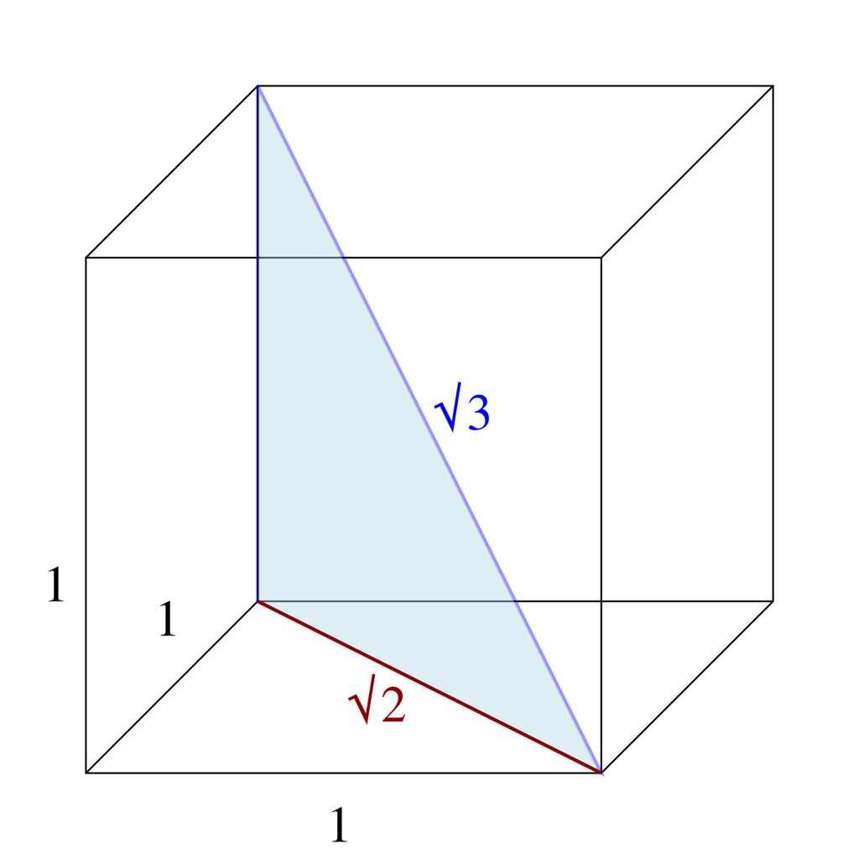
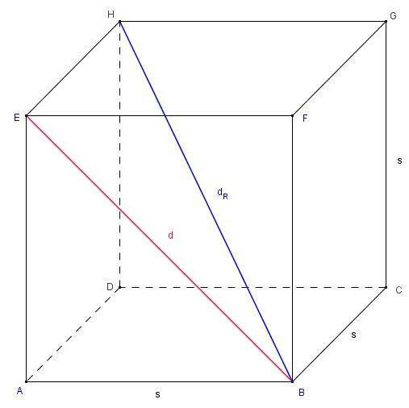
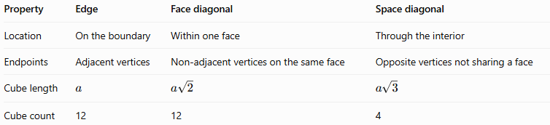
Property | Edge | Face diagonal | Space diagonal
Location | On the boundary | Within one face | Through the interior
Endpoints | Adjacent vertices | Non-adjacent vertices on the same face | Opposite vertices not sharing a face
Cube length | $$a$$ | $$a\sqrt{2}$$ | $$a\sqrt{3}$$
Cube count | 12 | 12 | 4
For a cube with positive edge length $a$:
$$\boxed{a<a\sqrt{2}<a\sqrt{3}}$$
Thus, the space diagonal is longer than both an edge and a face diagonal.

Practical applications
# Source: AI Source: Provided by: [Data Path: Persons Table -> ID Column: 1, Name_En Column: Motasem Essam] -> From: [ChatGPT] on [7/25/2026]
- Architecture and construction: calculating the longest straight distance through a rectangular room or box-shaped structure.
- Packaging: determining whether a long object fits diagonally inside a box.
- Computer graphics: calculating distances between vertices in three-dimensional models.
- Engineering: measuring straight-line distances between points in a 3D structure.
- Coordinate geometry: finding the distance between two points in space.

Key points
# Source: AI Source: Provided by: [Data Path: Persons Table -> ID Column: 1, Name_En Column: Motasem Essam] -> From: [ChatGPT] on [7/25/2026]
- A space diagonal connects vertices through the interior of a solid.
- It does not lie entirely on a face or along an edge.
- The space diagonal of a cube is $d=a\sqrt{3}$.
- The space diagonal of a cuboid is $d=\sqrt{l^{2}+w^{2}+h^{2}}$.
- A cube and a cuboid each have four space diagonals.
- A tetrahedron has no space diagonals under the standard definition.
- The general three-dimensional distance formula can be used to calculate a space diagonal from coordinates.

Conclusion
# Source: AI Source: Provided by: [Data Path: Persons Table -> ID Column: 1, Name_En Column: Motasem Essam] -> From: [ChatGPT] on [7/25/2026]
A space diagonal is an important type of line segment in solid geometry because it measures a straight-line distance through the interior of a three-dimensional solid. Its formulas follow from the Pythagorean theorem and extend naturally to coordinate geometry.

